**Test Cases**

**Black Box Testing**

**Login**

|  |  |  |  |  |
| --- | --- | --- | --- | --- |
| Risk Level | Input | Expected Output | Actual Output | Pass/Fail |
| High | User enter:   * Wrong username * Correct password | “Invalid login” | “Invalid login” | Pass |
| High | User enter:   * Correct username * Wrong password | “Invalid login” | “Invalid login” | Pass |
| High | User enter:   * Correct username * Correct password | User gets directed to home page | User gets directed to home page | Pass |

**Forget password**

|  |  |  |  |  |
| --- | --- | --- | --- | --- |
| Risk Level | Input | Expected Output | Actual Output | Pass/Fail |
| Medium | User input:   * Blank username | “Invalid username” | “invalid username” | Pass |
| Medium | User input:   * Valid username | * New password sent to user’s email * Redirect to login page | * New password sent to user’s email * Redirect to login page | Pass |
|  | User input:   * Invalid username | “Invalid username” | “Invalid username” | Pass |

**Signup**

|  |  |  |  |  |
| --- | --- | --- | --- | --- |
| Risk Level | Input | Expected Output | Actual Output | Pass/Fail |
| High | User enter:   * Blank username * Password not blank * “Email” not blank | “Username cannot be blank” | “Username cannot be blank” | Pass |
| High | User enter:   * Username not blank * Username taken * Password not blank * “Email” not blank | “Username have already been taken” | “Username have already been taken” | Pass |
| High | User enter:   * Username not blank * Username not taken * Password blank * “Email” not blank | “Password cannot be blank” | “Password cannot be blank” | Pass |
| High | User enter:   * Username not blank * Username not taken * Password not blank * “Email” blank | “Email cannot be blank” | “Email cannot be blank” | Pass |
| High | User enter:   * Username not blank * Username not taken * Password not blank * “Email” not blank | Redirect user to home page | Redirect user to home page | Pass |

**White Box Testing**

**Search/Advance search**

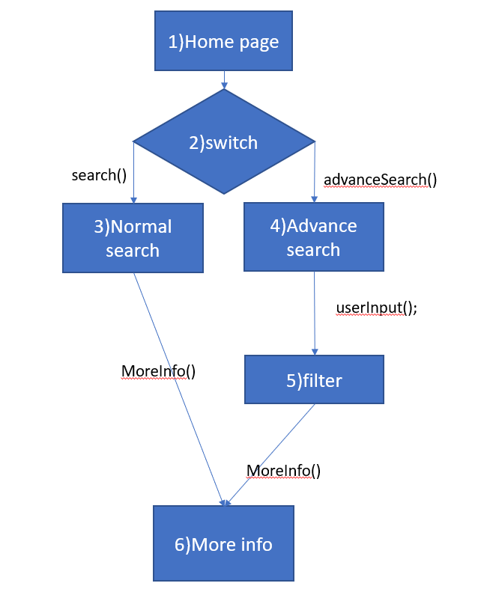

Number of Nodes = 6

Number of Edges = 6

CC= Number of Edges – Number of nodes + 2

= 6-6+2

= 2

|  |  |
| --- | --- |
| Basis path | Test cases |
| 1, 2, 3, 6 (baseline) | switch: search() |
| 1, 2, 4, 5, 6 | switch: advanceSearch() |

**More Info**

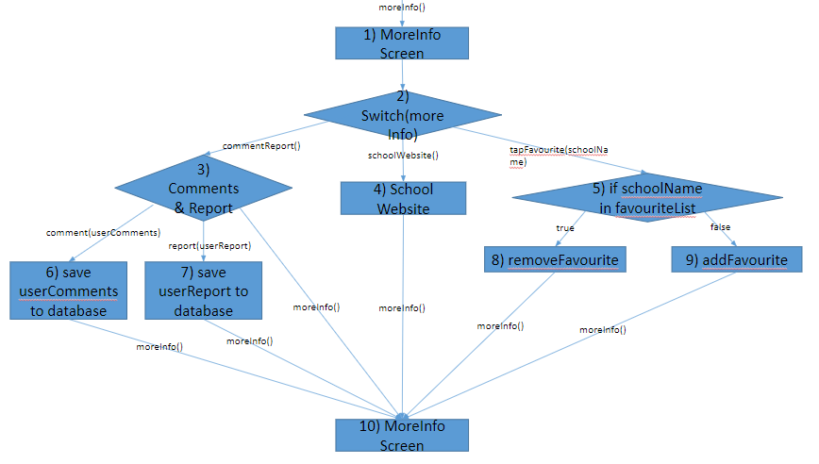

Number of Nodes = 10

Number of Edges = 14

CC = Number of Edges – Number of nodes + 2

= 14–10+2

= 6

|  |  |
| --- | --- |
| Basis Path | Test Cases |
| 1,2,4,10 (Baseline) | schoolWebsite(), moreInfo() |
| 1,2,3,6,10 | 1,2,5,9,10 |
| 1,2,3,7,10 | commentReport(), report(), moreInfo() |
| 1,2,3,10 | commentReport(), moreInfo() |
| 1,2,5,8,10 | tapFavourite(), schoolName in favouriteList |
| 1,2,5,9,10 | tapFavourite(), schoolName not in favouriteList |